**PROJECT OF FRONT**

**END ENGINEERING**

Name:- Akshinder Singh Sondhi

Roll Number:- 2110990132

Group :- G5

Branch :- B.E,C.S.E(5th Sem)

* This project is a front end of an e-commerce website which sells electronic devices like smartphones , laptops etc.
* The aim for making this website was to make only shopping easy and affordable .
* The name of the website is [www.elecshop.com](http://www.elecshop.com/) .
* The reason behind for choosing this name is that this name is made up by 2 names ‘elec’ and ‘shop’ there combination signifies the electronic shopping .
* In this website the three major languages are used that is HTML , CSS and JAVASCRIPT .
* The code editor used to make this website is Visual studio code.
* The browsers used are Chrome , Edge and Firefox.
* This website contains 20 pages .
* The list of pages is :-
* Home
* Login
* Demo
* Contact Us
* About Us
* Category
* 8 pages of product details
* 6 pages for products of a specific category
* Approximately 30 to 40 images are added in it.
* Let’s go through the website.
* Almost , every page consist of header and footer sections .
* The header section contains the logo of the website and the navigation options which on clicking take us to that page .
* The footer sections contains many things like our address , the companies social media links , privacy policies , terms and conditions , there are the options which are helpful for the customers like track my order , view cart etc .
* First of all , when we enter the website the home page opens .

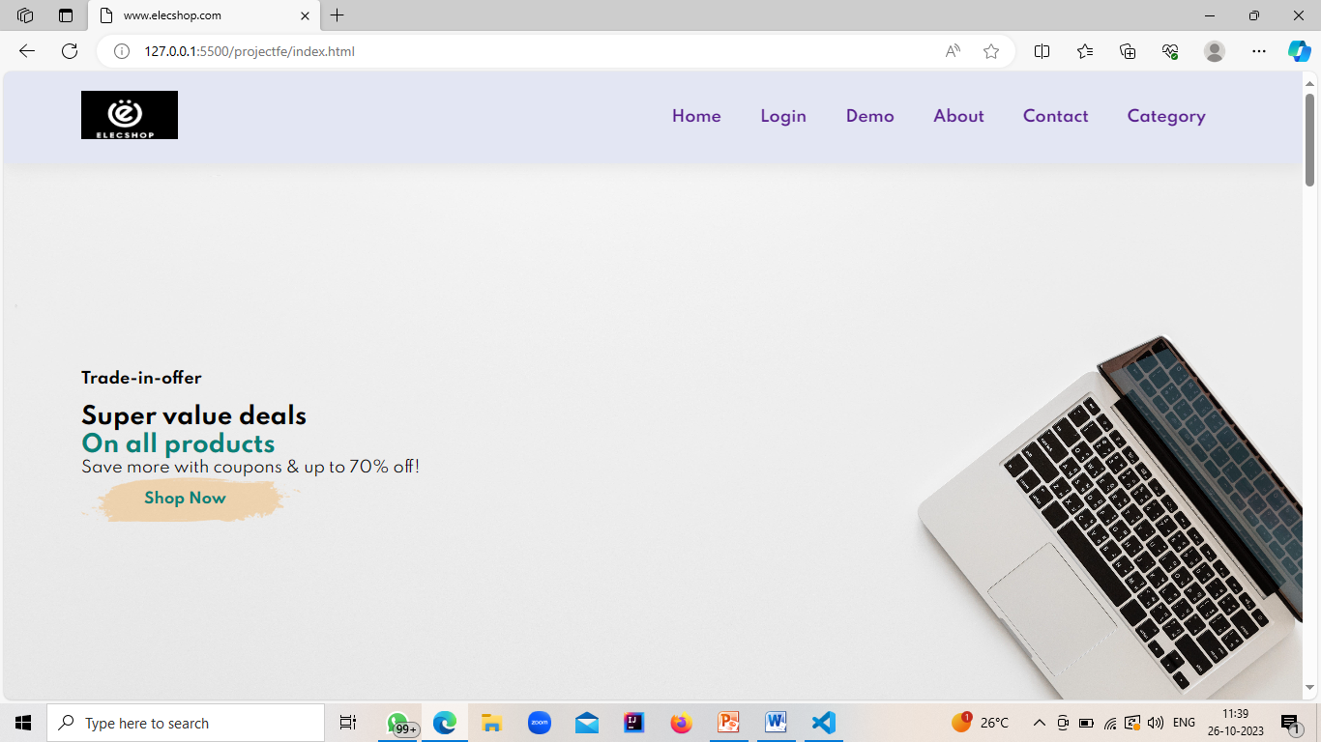

As we scroll down the home page , then there comes Shopping cart list which shows the list of products you added on cart and do total of prices of products and shows . After it , then comes the list of services which the website and company provides to there customers . The next thing that comes is the searching the products with their category like if put a company’s name in that search box it will filter the products and show you the products only of that company .

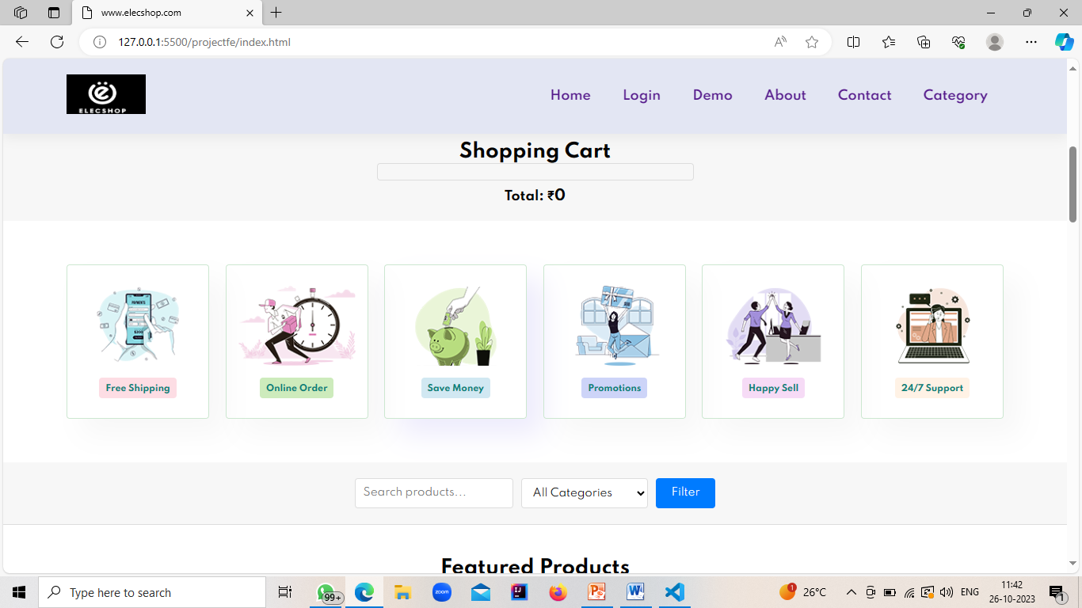

As we scroll down

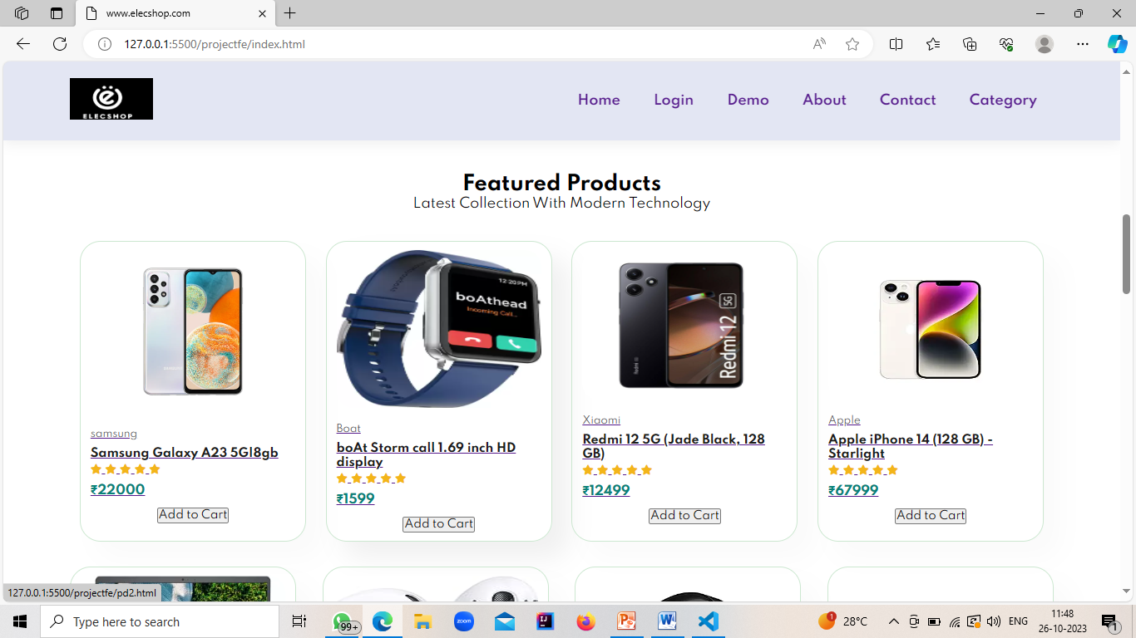

Here comes some featured products which the customer can visit and purchase .

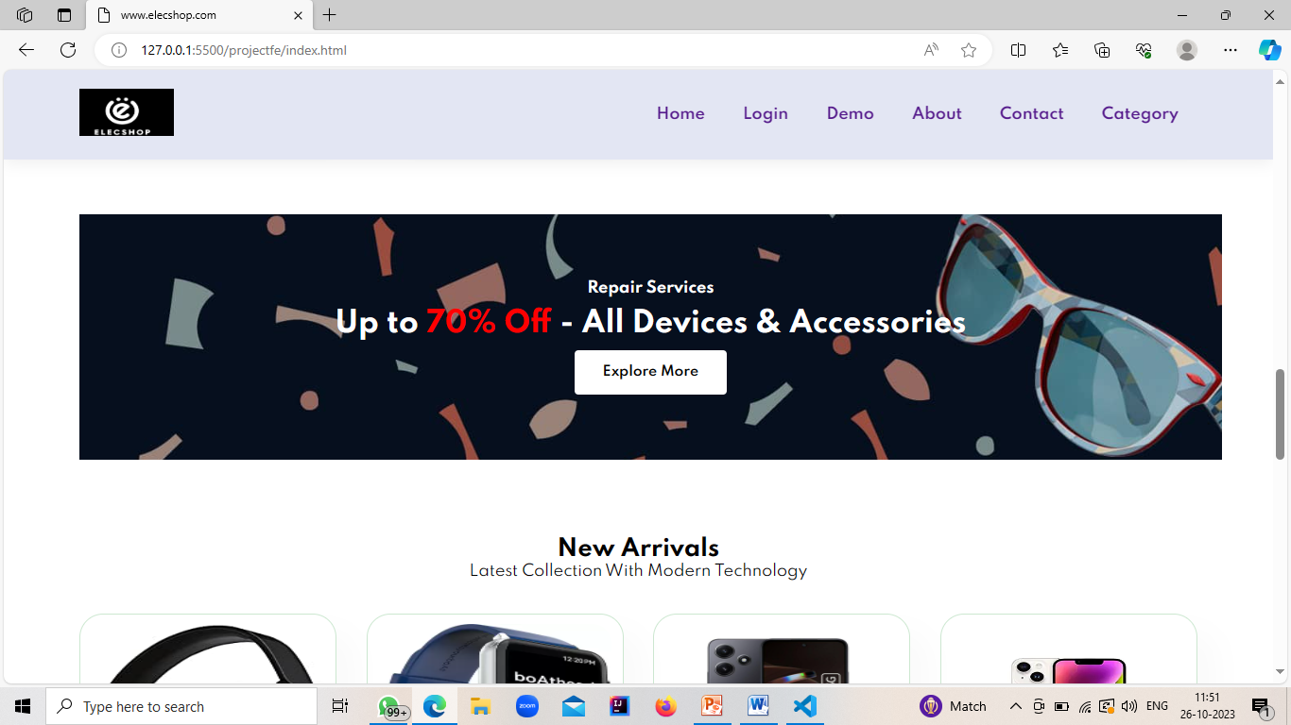

In between, there are some banners showing the schemes launched by the company for the customers . Below it , there comes some new arrivals which can customer visit and purchase.

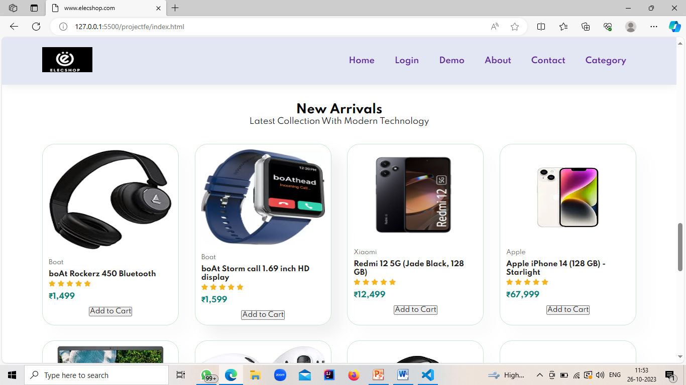

At the end , there are some more add banners and the footer section.

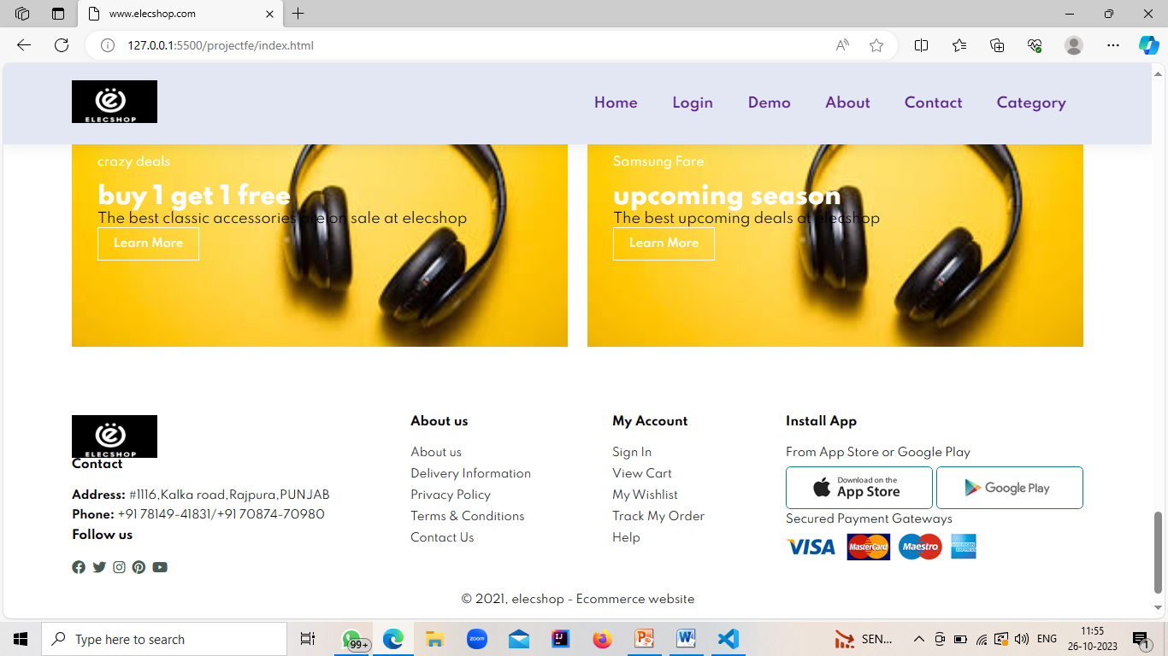

So , this was all about the home page of the website.

* Now, let’s see the login page.

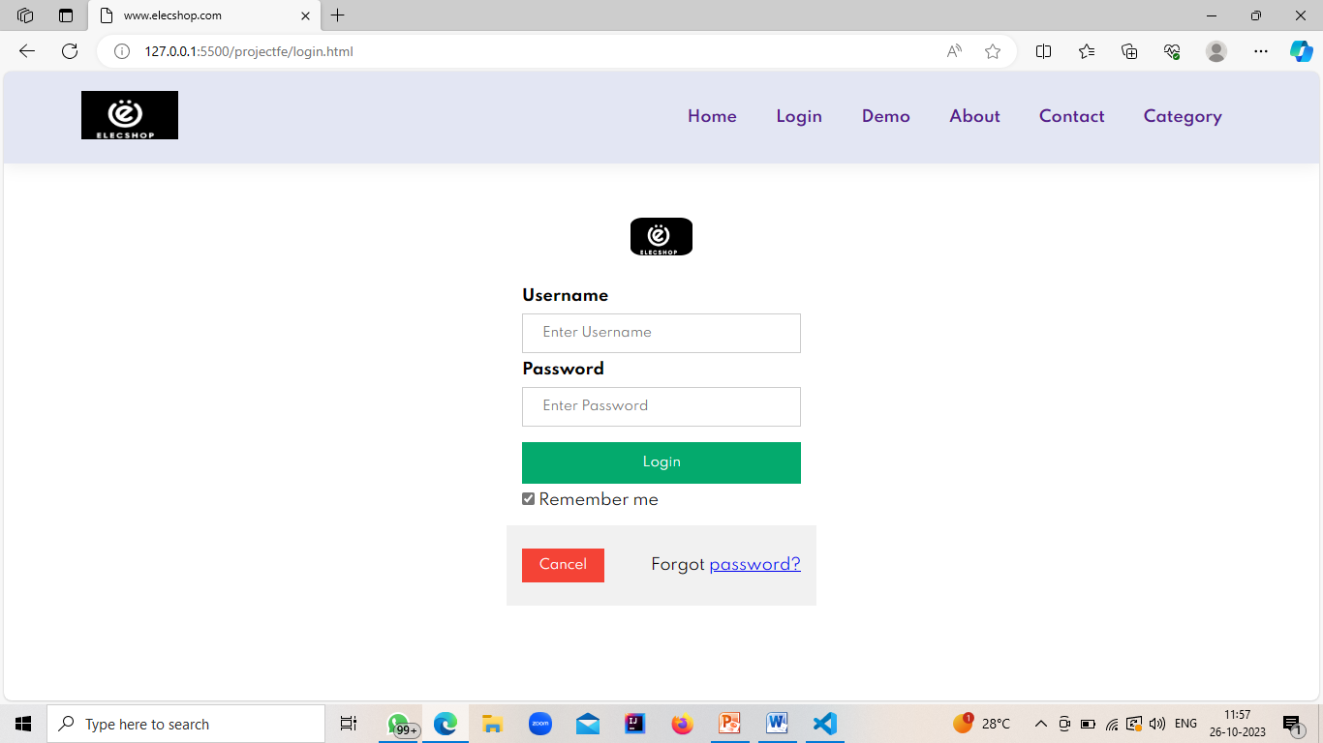

It is having a logo in the middle which if the company , and next thing is a form which asks the user for his/her Username and password to login . It is also added with the forgot password option , in any case , if customer forgots it he/she can reset it.

* The next page is demo page.

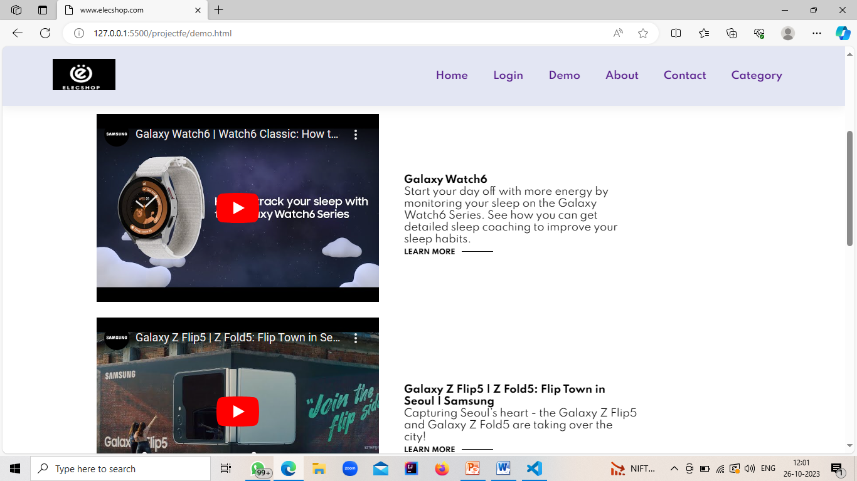

It shows the videos of different products from the social media sites . It is done so that a customer can see the working and features more clearly of any product .

* Further let’s proceed to about us page.

It tells the customer from where we started , who we are , what’s are purpose , our moto and many more things that can build a good relationship between the compay and the customer.

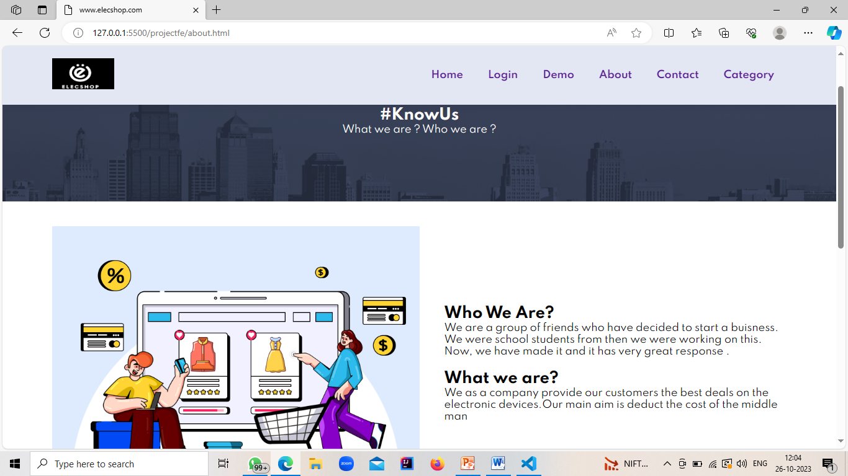

* The next page is of contact us.

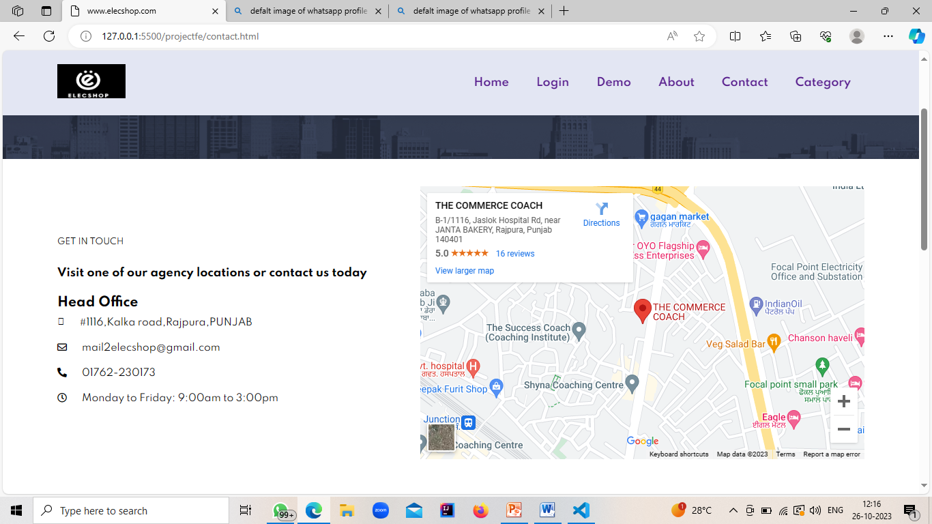

In this page I have added location(map),email id, telephone number , etc. It has been done if in any case customer wants to contact us for any help he/she can do it easily. I also added a feedback form for customers to give any suggestions , even the contacts of the senior authorities of company.

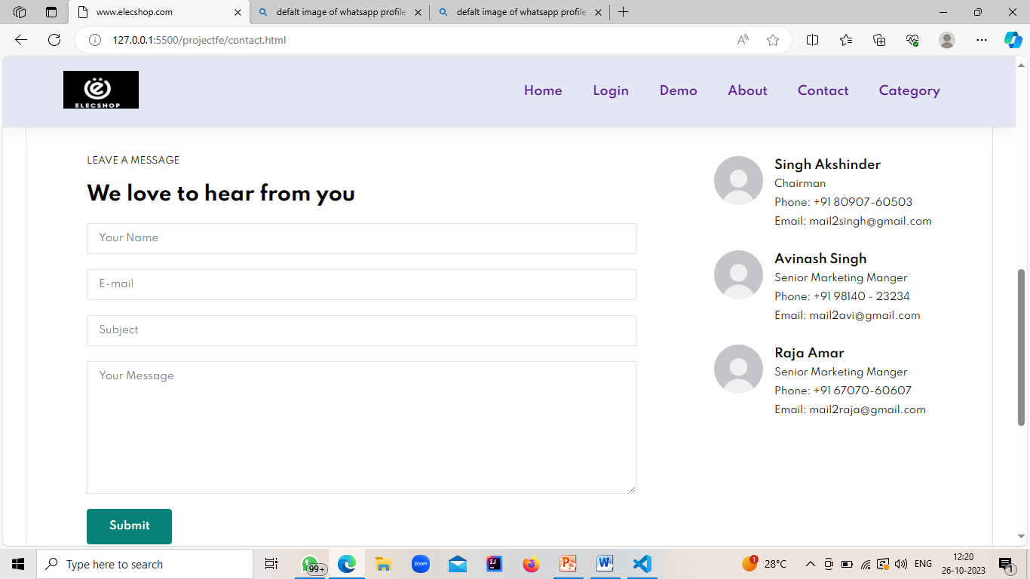

* The next page is category page .

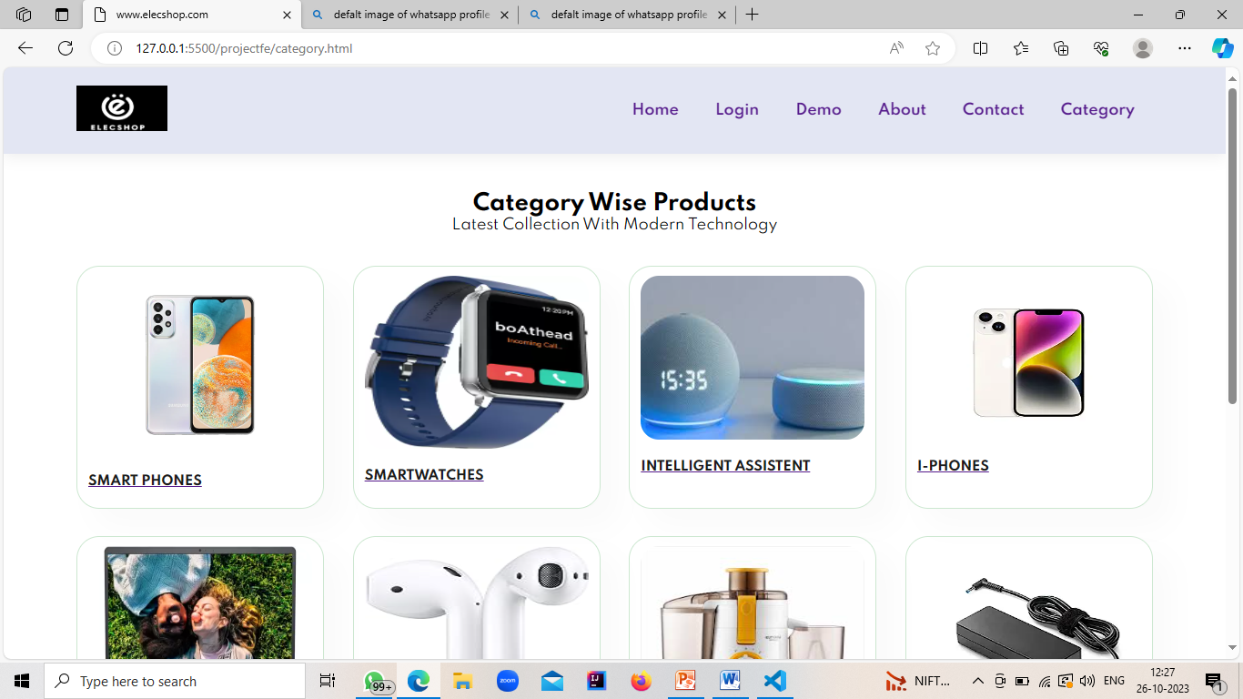

In this the products are distributed according to their categories . It is been done for the ease of the customers like if a customer has visited to buy an I-phone if he/she will click on that section he will see the options for the i-phones , which will be easy for him and also reduces the time.

* Now , let’s see our page when we click on any category page.



Like we have clicked on smartphones , the page is only showing us different options for smartphones.

* If we click on the any product the product features page will open .

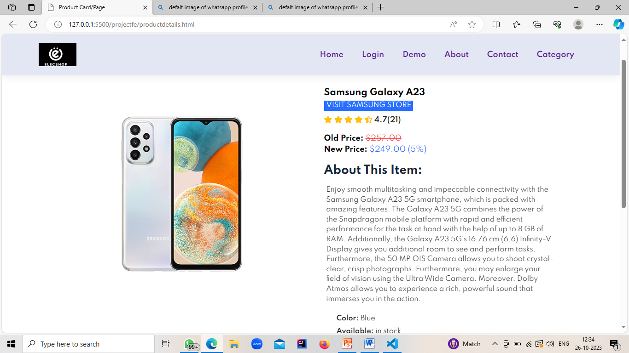

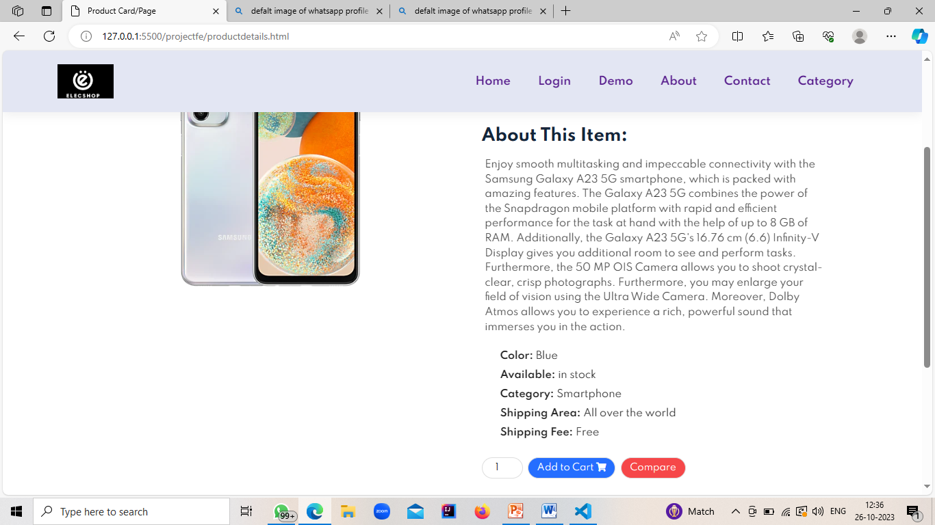

It will show us the ratings , price , about that item , colors , availability etc.

Thank you!